//table2-1125
//tobit with same variables but without attachment and perspective (male and female separately).
//male
tobit amount treatment like_dona climate community connection if gender == 0, ll(0) ul(180)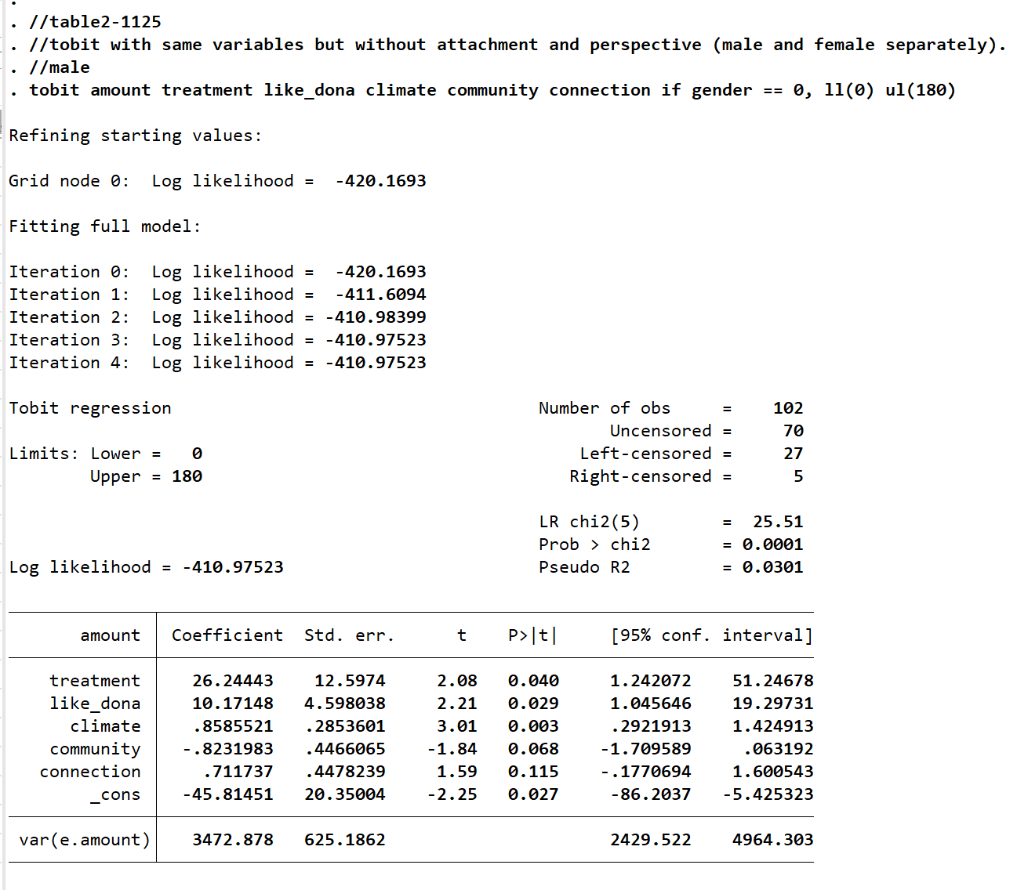
//female
tobit amount treatment like_dona climate community connection if gender == 1, ll(0) ul(180)
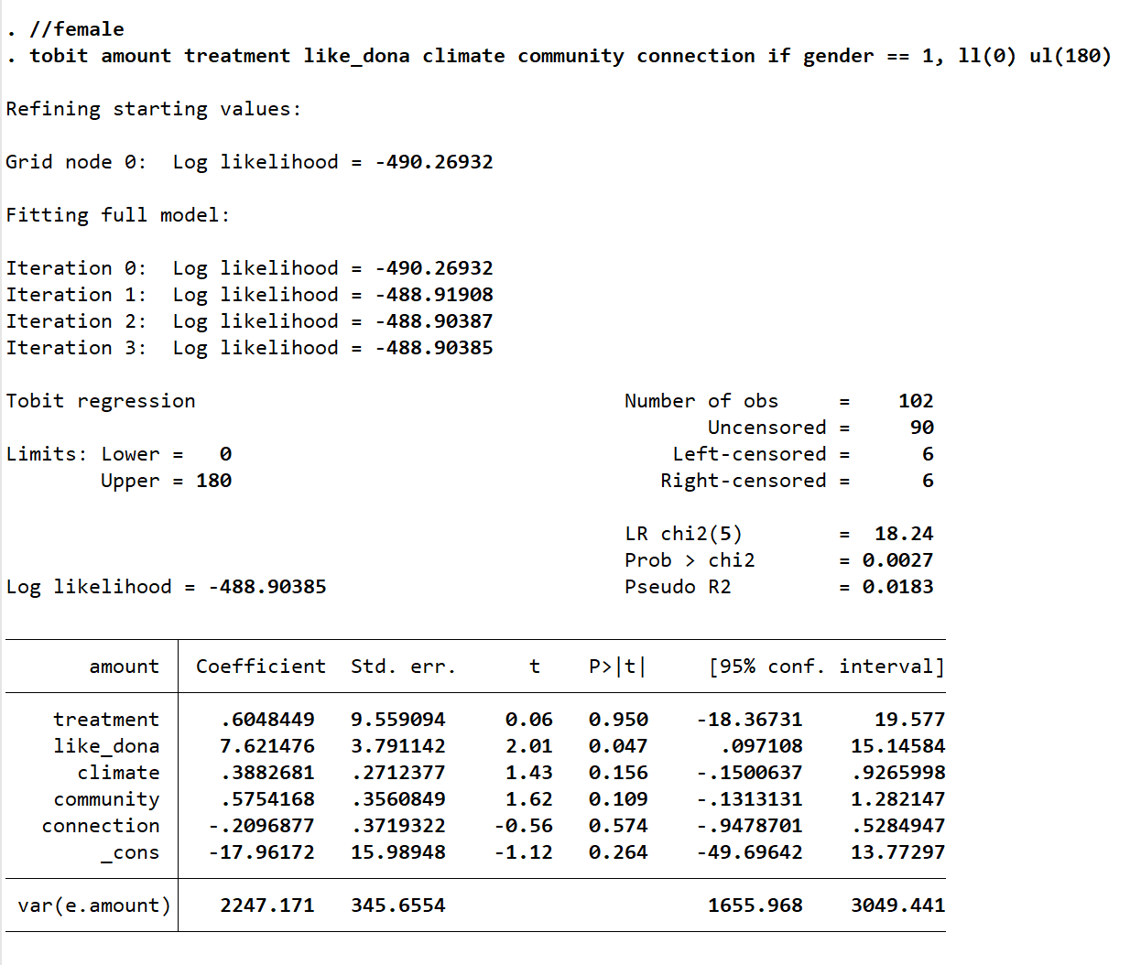
//donation
ttest amount, by(treatment)

display "Control mean: " %9.1f r(mu_1)
display "Treatment mean: " %9.1f r(mu_2)
display "Difference: " %9.1f (r(mu_2) - r(mu_1))
display "p (one-tailed): " %9.3f (r(p)/2)
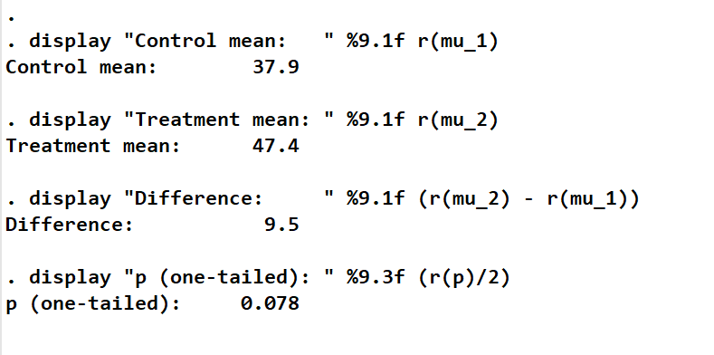
Gender-male
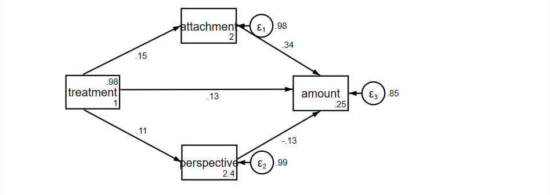
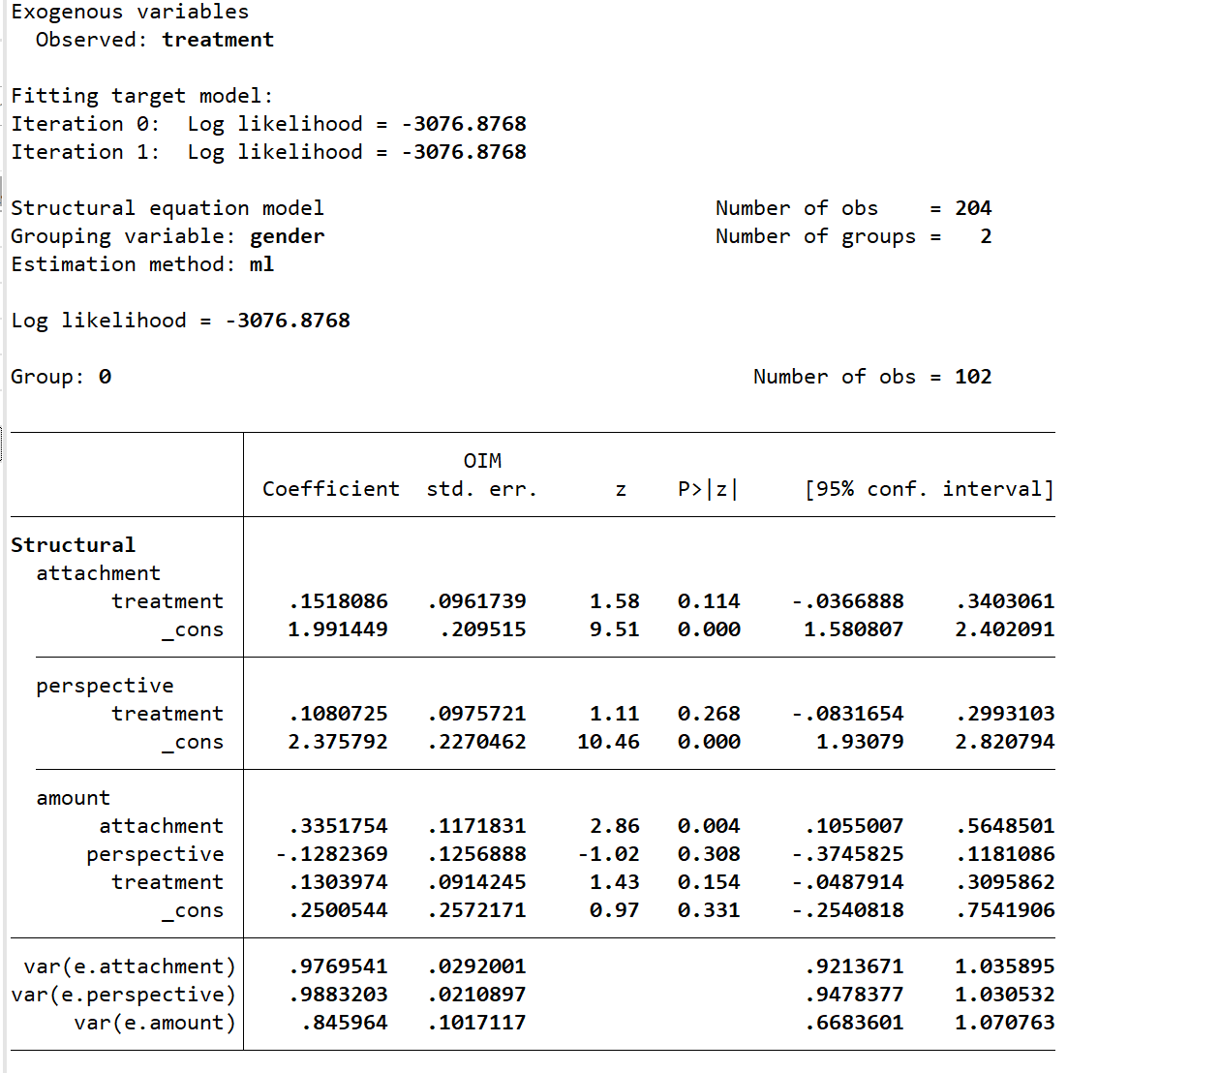

Gender-female
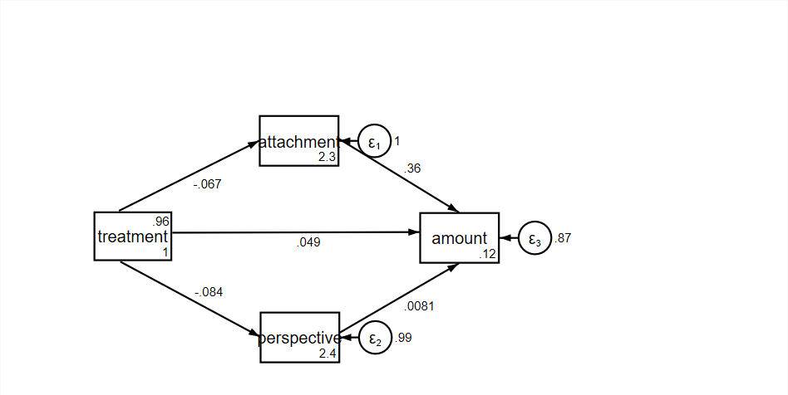
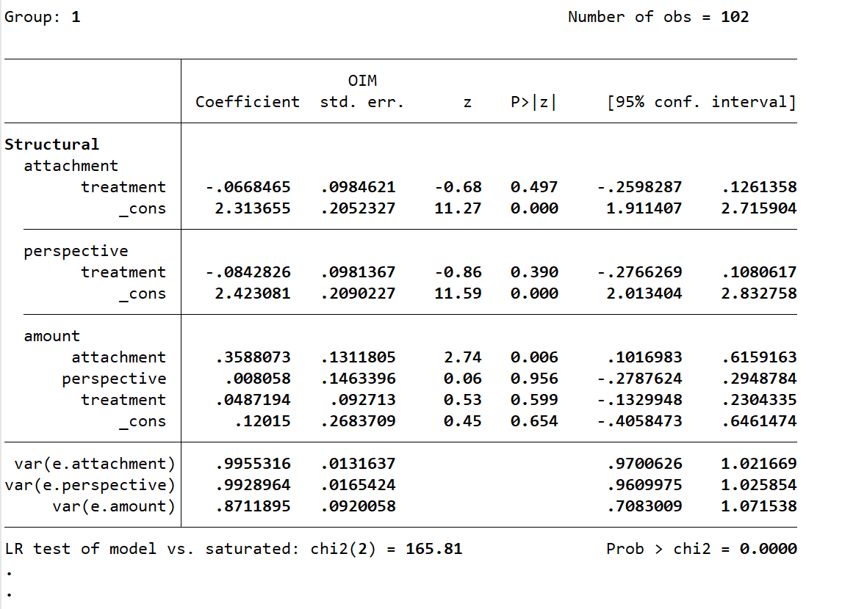

//all(without attachment and perspective)
tobit amount treatment like_dona climate community connection , ll(0) ul(180)
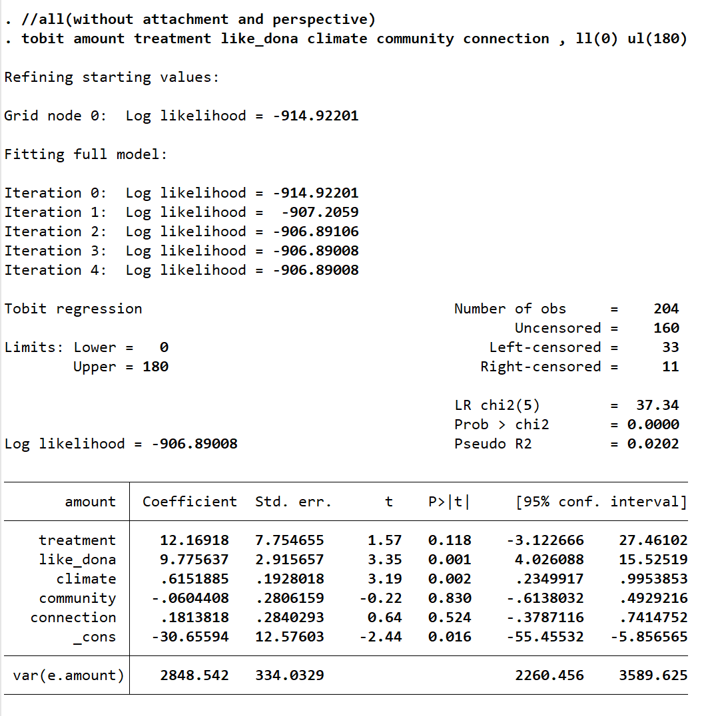
//all(with attachment and perspective)
tobit amount treatment like_dona attachment climate community connection perspective, ll(0) ul(180)
