Survey-UG

Start of Block: Block 1

Q1 Are you currently an undergraduate student?
- Yes
- No

End of Block: Block 1

Start of Block: Block2 Basic Info

Q2 Is this your first, second, third, or fourth year as an undergraduate student at HKUST?
- 1st
- 2nd
- 3rd
- 4th

Q3 Please let us know your gender (either chosen or listed at birth).
- Female
- Male

Q4 What is your age (in years)?
________________________________________________________________

Q5 Please write down your major (e.g., engineering, psychology) at HKUST.
________________________________________________________________

Q6 In what city were you born?
________________________________________________________________

End of Block: Block2 Basic Info

Start of Block: Block3

Q7 Ideally, when you have a steady income in the future, what percentage of your annual income do you think you will be donating to charitable and/or environmental causes? (Please enter a number)
________________________________________________________________

Q8 How likely are you to donate to a charitable cause over the next year?
- 0 = will not
- 1 = will likely not
- 2 = slight chance
- 3 = medium chance
- 4 = great chance
- 5 = will surely donate

Q9 In the following exercise, enter your degree of disagreement or agreement with each of the following statements. “Humans have the right to modify the natural environment to suit their needs”
- 0 = totally disagree
- 1 = rather disagree
- 2 = undecided
- 3 = rather agree
- 4 = totally agree

Q10 “Humans are severely abusing the planet”
- 0 = totally disagree
- 1 = rather disagree
- 2 = undecided
- 3 = rather agree
- 4 = totally agree

Q11 “Plants and animals have the same right to exist as humans”
- 0 = totally disagree
- 1 = rather disagree
- 2 = undecided
- 3 = rather agree
- 4 = totally agree

Q12 “Nature is strong enough to cope with the impacts of modern industrial nations”
- 0 = totally disagree
- 1 = rather disagree
- 2 = undecided
- 3 = rather agree
- 4 = totally agree

Q13 “Humans were meant to rule over the rest of nature”
- 0 = totally disagree
- 1 = rather disagree
- 2 = undecided
- 3 = rather agree
- 4 = totally agree

Q14 “The balance of nature is very delicate and easily upset”
- 0 = totally disagree
- 1 = rather disagree
- 2 = undecided
- 3 = rather agree
- 4 = totally agree

End of Block: Block3

Start of Block: Male Control Group

Q15 In the following exercise, you will be asked to determine a reasonable allocation of a sum of money to yourself and, also, to an ecological conservation program in Hong Kong. By preserving natural habitat, forest areas, and endangered species, program staff try to improve the local ecology as well as trying to address climate change. This is a real exercise, so the monetary amounts you indicate will be actually paid (in supermarket coupons) to yourself and to the conservation program. (Within a week after the online survey, you will receive an email with instructions about when and where to collect the coupons. Note that your answers are strictly confidential, and the staff member handing the sealed envelopes will not know the amount of money inside them.)

Q16 Question: We will provide you with a total amount of one hundred eighty Hong Kong dollars (HKD180) to divide up: some portion to yourself (as personal income), and the remainder to the ecological conservation program. How much of the HKD180 would you like to donate to the ecological conservation program? (You keep the remainder.) (Note: The amount entered has to be an integer between 0 and 180. Otherwise, the number cannot be entered.)
________________________________________________________________

Q17 The following is a hypothetical question. Hypothetical Question: You are still going to divide up HKD180 as before, but this time, suppose that the project would match your donation to the conservation program (that is, double the amount you give to the program). How much of the HKD180 would you like to donate to the conservation program if there is a matching grant? (Note: The amount entered has to be an integer between 0 and 180. Otherwise, the number cannot be entered.)
________________________________________________________________

Q18 Over the next five years, how many times (in total) do you think you will volunteer to participate in an activity held by an ecological/environmental conservation program (whether in Hong Kong or elsewhere)? (Please enter a number)
________________________________________________________________

End of Block: Male Control Group

Start of Block: Male Test Group

Q19 In the following exercise, you will be asked to determine a reasonable allocation of a sum of money to yourself and, also, to an ecological conservation program in Hong Kong (see picture of site below). By preserving natural habitat, forest areas, and endangered species, program staff try to improve the local ecology as well as trying to address climate change. This is a real exercise, so the monetary amounts you indicate will be actually paid (in supermarket coupons) to yourself and to the conservation program. (Within a week after the online survey, you will receive an email with instructions about when and where to collect the coupons. Note that your answers are strictly confidential, and the staff member handing the sealed envelopes will not know the amount of money inside them.)
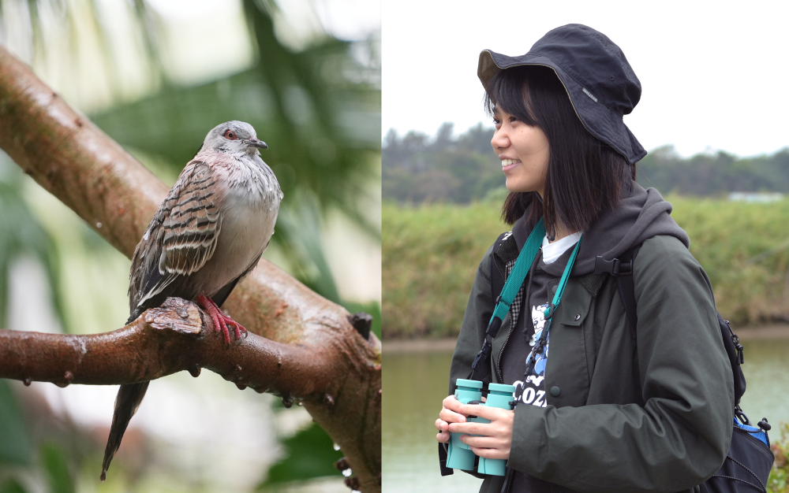

Q20 Question: We will provide you with a total amount of one hundred eighty Hong Kong dollars (HKD180) to divide up: some portion to yourself (as personal income), and the remainder to the ecological conservation program. How much of the HKD180 would you like to donate to the ecological conservation program? (You keep the remainder.) (Note: The amount entered has to be an integer between 0 and 180. Otherwise, the number cannot be entered.)
________________________________________________________________

Q21 The following is a hypothetical question. Hypothetical Question: You are still going to divide up HKD180 as before, but this time, suppose that the project would match your donation to the conservation program (that is, double the amount you give to the program). How much of the HKD180 would you like to donate to the conservation program if there is a matching grant? (Note: The amount entered has to be an integer between 0 and 180. Otherwise, the number cannot be entered.)
________________________________________________________________

Q22 Over the next five years, how many times (in total) do you think you will volunteer to participate in an activity held by an ecological/environmental conservation program (whether in Hong Kong or elsewhere)? (Please enter a number)
________________________________________________________________

End of Block: Male Test Group

Start of Block: Female Control Group

Q23 In the following exercise, you will be asked to determine a reasonable allocation of a sum of money to yourself and, also, to an ecological conservation program in Hong Kong. By preserving natural habitat, forest areas, and endangered species, program staff try to improve the local ecology as well as trying to address climate change. This is a real exercise, so the monetary amounts you indicate will be actually paid (in supermarket coupons) to yourself and to the conservation program. (Within a week after the online survey, you will receive an email with instructions about when and where to collect the coupons. Note that your answers are strictly confidential, and the staff member handing the sealed envelopes will not know the amount of money inside them.)

Q24 Question: We will provide you with a total amount of one hundred eighty Hong Kong dollars (HKD180) to divide up: some portion to yourself (as personal income), and the remainder to the ecological conservation program. How much of the HKD180 would you like to donate to the ecological conservation program? (You keep the remainder.) (Note: The amount entered has to be an integer between 0 and 180. Otherwise, the number cannot be entered.)
________________________________________________________________

Q25 The following is a hypothetical question. Hypothetical Question: You are still going to divide up HKD180 as before, but this time, suppose that the project would match your donation to the conservation program (that is, double the amount you give to the program). How much of the HKD180 would you like to donate to the conservation program if there is a matching grant? (Note: The amount entered has to be an integer between 0 and 180. Otherwise, the number cannot be entered.)
________________________________________________________________

Q26 Over the next five years, how many times (in total) do you think you will volunteer to participate in an activity held by an ecological/environmental conservation program (whether in Hong Kong or elsewhere)? (Please enter a number)
________________________________________________________________

End of Block: Female Control Group

Start of Block: Female Test Group

Q27 In the following exercise, you will be asked to determine a reasonable allocation of a sum of money to yourself and, also, to an ecological conservation program in Hong Kong (see picture of site below). By preserving natural habitat, forest areas, and endangered species, program staff try to improve the local ecology as well as trying to address climate change. This is a real exercise, so the monetary amounts you indicate will be actually paid (in supermarket coupons) to yourself and to the conservation program. (Within a week after the online survey, you will receive an email with instructions about when and where to collect the coupons. Note that your answers are strictly confidential, and the staff member handing the sealed envelopes will not know the amount of money inside them.)

Q28 Question: We will provide you with a total amount of one hundred eighty Hong Kong dollars (HKD180) to divide up: some portion to yourself (as personal income), and the remainder to the ecological conservation program. How much of the HKD180 would you like to donate to the ecological conservation program? (You keep the remainder.) (Note: The amount entered has to be an integer between 0 and 180. Otherwise, the number cannot be entered.)
________________________________________________________________

Q29 The following is a hypothetical question. Hypothetical Question: You are still going to divide up HKD180 as before, but this time, suppose that the project would match your donation to the conservation program (that is, double the amount you give to the program). How much of the HKD180 would you like to donate to the conservation program if there is a matching grant? (Note: The amount entered has to be an integer between 0 and 180. Otherwise, the number cannot be entered.)
________________________________________________________________

Q30 Over the next five years, how many times (in total) do you think you will volunteer to participate in an activity held by an ecological/environmental conservation program (whether in Hong Kong or elsewhere)? (Please enter a number)
________________________________________________________________

End of Block: Female Test Group

Start of Block: Block 3

Q31 On a scale of 0 to 100, how much emotional attachment or concern do you feel for the ecological animals, plants, and people being helped by the project? (Note: you have to enter a number between 0 and 100.)
________________________________________________________________

Q32 On a scale of 0 to 100, how much are you able to take the perspective of, and understand the position of, the people (or even the other species) involved in the project? (Note: you have to enter a number between 0 and 100.)
________________________________________________________________

End of Block: Block 3

Start of Block: Block 4

Q33 This is the last part of the survey. Please answer the following questions.

Q34 On a scale of 0 to 100, how much do you feel a sense of connection or oneness with the natural world around you? (Note: you have to enter a number between 0 and 100.)
________________________________________________________________

Q35 On a scale of 0 to 100, how much do you think of the natural world as a community to which you belong? (Note: you have to enter a number between 0 and 100.)
________________________________________________________________

Q36 On a scale of 0 to 100, how concerned are you about climate change? (Note: you have to enter a number between 0 and 100.)
________________________________________________________________

Q37 What would you say your household/family income has been in recent years? (For example, if you lived with parents prior to moving to campus, what is their total annual income)?
________________________________________________________________

Q38 How much money do you spend, in total, for food, transportation, and other expenses (including rent and utilities) each month?
________________________________________________________________

Q43 IMPORTANT: Please enter your email address in the space provided below. We need your email address to arrange for the compensation. Enter your complete email address here:
________________________________________________________________

End of Block: Block 4

